|  |
| --- |
| **DAYANANDA SAGAR UNIVERSITY**  Devarakaggalahalli, Harohalli  Kanakapura Road, Ramanagara - 562112, Karnataka, India   |

**Bachelor of Technology**

**in**

**COMPUTER SCIENCE AND TECHNOLOGY**

**Full Stack Development**

**Mini Project Report**

**PEAK XP**

By

**M DIXITH ADITHYA - ENG23CT1005**

**NISCHITH R - ENG23CT0011**

**KARTHIK H S - ENG23CT0008**

**PRATHAM B LIMBANI - ENG23CT0013**

**CHETHAN G - ENG23CT1004**

**Under the supervision of**

**Ms. YASHASWINI**

**Assistant Professor**

**DEPARTMENT OF COMPUTER SCIENCE & TECHNOLOGY**

**DEPARTMENT OF COMPUTER SCIENCE & TECHNOLOGY, SCHOOL OF ENGINEERING,**

**DAYANANDA SAGAR UNIVERSITY.**

**(2024-2025)**

**DAYANANDA SAGAR UNIVERSITY**

Department of Computer Science & Technology

Devarakaggalahalli, Harohalli

Kanakapura Road, Ramanagara - 562112, Karnataka, India.

CERTIFICATE

This is to certify that the Full Stack Development Mini Project work titled **“PEAK XP”** is carried out by **M DIXITH ADITHYA (ENG23CT1005), NISCHITH R (ENG23CT0011),** **KARTHIK H S (ENG23CT0008), PRATHAM B LIMBANI (ENG23CT0013),** **CHETHAN G (ENG23CT1004),** Bonafide students of Third semester of Bachelor of Technology in Computer Science and Technology at the School of Engineering, Dayananda Sagar University, Bangalore in partial fulfillment for the award of degree in Bachelor of Technology in Computer Science and Technology, during the year **2024-2025**.

|  |  |
| --- | --- |
| **Ms. Yashaswini** | **Dr. Shahina Parveen** |
| Assistant Professor  Dept. of CS&T,  School of Engineering  Dayananda Sagar University  Date: | Chairman CST  School of Engineering  Dayananda Sagar University  Date: |

**Name of the Examiner** **Signature of Examiner**

<

DECLARATION

We, **M DIXITH ADITYA(ENG23CT1005), NISCHITH R (ENG23CT0011),** **KARTHIK H S (ENG23CT0008), PRATHAM B LIMBANI (ENG23CT0013),** **CHETHAN G (ENG23CT1004),** are students of Third semester B. Tech in **Computer Science and Technology**, at School of Engineering, **Dayananda Sagar University**, hereby declare that the Mini Project titled **“PEAK XP”** has been carried out by us and submitted in partial fulfilment for the award of degree in **Bachelor of Technology in Computer Science and Technology** during the academic year **2024‑2025.**

|  |  |
| --- | --- |
| Student | Signature |
| M DIXITH ADITHYA  ENG23CT1005 |  |
| NISCHITH R  ENG23CT0011 |  |
| KARTHIK H S  ENG23CT0008 |  |
| PRATHAM B LIMBANI  ENG23CT0013 |  |
| CHETHAN G  ENG23CT1004 |  |
| Place : Bangalore  Date : |  |

**ACKNOWLEDGEMENT**

*It is a great pleasure for us to acknowledge the assistance and support of many individuals who have been responsible for the successful completion of Full Stack Development mini project work.*

*First, we take this opportunity to express our sincere gratitude to School of Engineering & Technology, Dayananda Sagar University for providing us with a great opportunity to pursue our Bachelor’s degree in this institution.*

*We would like to thank* ***Dr. Udaya Kumar Reddy K R, Dean, School of Engineering & Technology, Dayananda Sagar University*** *for his constant encouragement and expert advice.*

*It is a matter of immense pleasure to express our sincere thanks to* ***Dr.*Shahina Parveen,*****Department Chairperson****,* ***Computer Science and Technology****,* ***Dayananda Sagar University,*** *for providing right academic guidance that made our task possible.*

*We would like to thank our guide* ***Ms Yashaswini.****,****Assistant Professor****,* ***Dept. of Computer Science and Technology****,* ***Dayananda Sagar University****, for sparing her valuable time to extend help in every step of our project work, which paved the way for smooth progress and fruitful culmination of the project.*

*We are also grateful to our family and friends who provided us with every requirement throughout the course.*

*We would like to thank one and all who directly or indirectly helped us in the mini Project work.*

**TABLE OF CONTENTS**

LIST OF FIGURES

LIST OF TABLES

ABSTRACT

Page

CHAPTER 1 INTRODUCTION………................................................................. 1

CHAPTER 2 OVERVIEW OF PROJECT……..................................................... 2

2.1. Purpose and Goals.......................................................................... 3

2.2. Technologies Used........................................................................... 4

CHAPTER 3 FUNCTIONAL REQUIREMENTS..................................................... 5

CHAPTER 4 CODE SNIPPETS………...................................................................... 7

CHAPTER 5 RESULT………………………........................................................... 8

CONCLUSION……………………………………………………………………... 9

**LIST OF FIGURES**

|  |  |  |
| --- | --- | --- |
| Fig. No. | Description of the figure | Page No. |
| 5.1 | Login page | 8 |
| 5.2 | Home page | 8 |
| 5.3 | Habit progress | 8 |
| 5.4 | Habit progress(graphs) | 8 |
| 5.5 | XP & Rewards | 8 |
| 5.6 | Leaderboard |  |

**LIST OF TABLES**

|  |  |  |
| --- | --- | --- |
| Table No. | Description of the Table | Page No. |
| 2.1 | Key Features of PeakXP | 4 |

Abstract

This project report describes the development of Peak XP, a web-based platform that gamifies habit-building to foster consistency, motivation, and productivity. The platform addresses the challenge of maintaining long-term habits by integrating game-like elements into everyday routines. By leveraging technologies such as HTML, CSS, JavaScript, and MongoDB, the platform delivers a seamless experience for habit tracking, progress visualization, and goal achievement.

Peak XP allows users to add, monitor, and manage up to five habits through an interactive dashboard. Each habit includes features like progress tracking with real-time charts, task management, and automatic XP calculation based on user achievements. Users can claim rewards, participate in leaderboards, and compare progress with others, fostering a sense of friendly competition and accountability.

The ultimate goal of Peak XP is to make habit-building engaging, competitive, and rewarding, empowering users to unlock their "inner monster" and realize their full potential through consistency and discipline.

CHAPTER 1

INTRODUCTION

PeakXP is a comprehensive platform designed to help users improve their habits and achieve personal goals through gamification. By combining habit tracking, progress monitoring, and social competition, it offers a unique approach to self-improvement. The platform allows users to create and manage habits, track their progress with detailed graphs, and engage in challenges that promote healthy competition.

One of the core features of PeakXP is its personalized dashboard, which provides a clear view of a user’s habits and progress. Each habit comes with a dedicated progress page, allowing users to update their progress, visualize their achievements, and make adjustments as needed. Gamification elements, including XP points and rewards, further motivate users to stay consistent with their habits and unlock new milestones.

PeakXP also includes a leaderboard where users can see how they rank against others, fostering a sense of community and friendly competition. The system is powered by a robust backend and database infrastructure, ensuring data security and scalability for future growth. This report will explore PeakXP’s functionality, user experience, and its potential to inspire meaningful habit formation.

**CHAPTER 2**

**OVERVIEW OF PROJECT**

PeakXP is designed as a user-friendly platform that aims to transform habit-building into an engaging and motivating experience. The project combines essential features like habit creation, progress tracking, and gamification to provide users with a comprehensive tool for personal growth.

At its core, PeakXP offers users a personalized dashboard where they can add, manage, and track their habits. Each habit is linked to a detailed progress page, which includes graphs that visually represent the user’s progress over time. The platform tracks key metrics such as completion rates and durations, offering insights into how users are advancing toward their goals.

The system also incorporates a points-based gamification system, rewarding users with XP for consistent habit completion and offering redeemable rewards. The leaderboard feature fosters a sense of community by allowing users to compare their progress with others, encouraging a healthy level of competition.

Built using MongoDB for efficient data management, PeakXP ensures scalability, security, and flexibility, allowing it to adapt as new features are added. This platform is not just about tracking habits; it’s about creating a motivating environment that supports long-term personal development.

Table 21.1: Key Features of PeakXP

|  |  |
| --- | --- |
| **Features** | **Description** |
| Habit Tracking | Users can create, track, and update their habits, marking them as completed and monitoring progress over time. |
| Progress Tracking | Visual graphs and real-time updates display user progress for each habit, helping users monitor improvement. |
| Gamification & XP | Users earn XP points as they complete habits, which can be redeemed for rewards or used in competitions. |
| Leaderboard | A ranking system that displays the top users based on XP points, encouraging friendly competition. |
| Task Management | Users can create, update, and track tasks related to each habit, setting deadlines, priorities, and reminders. |
| Profile Management | Users can view and update their profile information, including name and email. |
| Rewards | |  | | --- | |  |  |  | | --- | | XP points can be used to unlock rewards or features within the platform, offering tangible incentives for progress. | |

**2.1. Purpose and Goals**

The primary purpose of PeakXP is to assist users in developing and maintaining productive habits by making the process more engaging and rewarding. The platform aims to provide users with the tools and motivation they need to turn their goals into actionable habits, ultimately leading to consistent self-improvement.

Key goals of PeakXP include:

* Empowering Habit Formation: To create a system that helps users establish new habits and sustain them over time by making the process more interactive and rewarding.
* Encouraging Consistency: Through gamification elements like XP points, rewards, and a leaderboard, PeakXP seeks to motivate users to stay consistent in their habit-building efforts.
* Promoting Progress Tracking: To provide users with a clear, visual representation of their progress, helping them stay informed about their achievements and identify areas for improvement.
* Building a Supportive Community: By integrating social elements like leaderboards, PeakXP aims to create a sense of community and healthy competition, allowing users to share their progress and be inspired by others.
* Ensuring Flexibility and Scalability: The platform is designed to be adaptable, allowing for future growth and new feature integrations, ensuring long-term value for users.

**2.2. Technologies Used**

PeakXP is built using a combination of modern web development technologies to ensure a seamless and efficient user experience. The following technologies are integral to the platform’s functionality:

1. **Frontend:**

* **HTML5, CSS3, and JavaScript**: These core web technologies form the backbone of the platform’s frontend, providing the structure, styling, and interactivity needed for the user interface.
* **React.js**: Used for building dynamic and responsive user interfaces. React allows for a smooth, real-time experience by efficiently updating the page as users interact with the platform.
* **Chart.js**: Integrated for visualizing habit progress through graphs, enabling users to track their performance over time in a clear, interactive format.

1. **Backend:**

* **Node.js**: The server-side JavaScript runtime used to handle backend operations. It enables a scalable and fast environment for handling requests and processing data.
* **Express.js**: A lightweight framework for Node.js that facilitates the creation of the API to manage user interactions, habit data, and progress updates.

1. **Database:**

* **MongoDB**: A NoSQL database that stores user data, habits, progress, and XP points. MongoDB’s flexibility in handling JSON-like data structures allows for easy management of user-specific information and scalable data storage.

These technologies collectively support the platform’s functionality, scalability, and user experience, making PeakXP a reliable and efficient tool for habit-building and progress tracking.

**CHAPTER 3**

**FUNCTIONAL REQUIREMENTS**

The PeakXP platform is designed to offer users an intuitive and engaging experience for tracking and building habits. The following functional requirements outline the essential features and capabilities of the platform to ensure smooth and effective operation:

1. User Registration and Login:

* Users must be able to create a new account by providing essential details, such as name, email, and password.
* A login system will be implemented, allowing users to securely log in using their credentials to access their personalized dashboard.
* The system must include a password reset feature, ensuring that users can recover their accounts if they forget their login details. Passwords must be securely hashed to ensure data protection.

1. Dashboard:

* After logging in, users will be presented with a personalized dashboard that showcases their active habits and progress.
* The dashboard will display a summary of all user habits, showing key metrics like completion rates and total time spent on each habit.
* Users can add up to five habits, specifying details such as the habit name, description, and target completion time. This feature allows for flexibility in managing a variety of habits.
* The dashboard will include clear links to each habit’s dedicated progress page and task management page for further engagement.

1. Progress Tracking:

* Users will be able to easily track the progress of each habit, marking tasks as completed and monitoring their overall success.
* Each habit will be linked to a graph that visually displays the user’s progress over time, offering insights into trends, improvements, and areas needing attention.
* The platform will allow users to manually update their progress, such as marking completion or entering time spent on the habit, ensuring real-time updates are reflected.

1. Gamification and XP System:

* PeakXP incorporates a gamified approach where users earn XP points as they progress through their habits, incentivizing consistent effort.
* XP points will be awarded for habit completion and milestones, helping users track their achievements and stay motivated.
* These XP points can be redeemed for rewards and exclusive features within the platform, creating a sense of accomplishment and value.
* A competitive leaderboard will rank users based on their XP points, offering a fun and motivating way to track performance relative to others.

1. Task Management:

* For each habit, users will be able to create and manage related tasks, adding further structure to their goals.
* Tasks can include setting deadlines, priorities, and reminders, ensuring that users have a clear roadmap for their progress.
* The "Tasks" button will redirect users to a dedicated task management page, where they can view, update, and complete tasks associated with each habit.

1. Profile Management:

* Users will have access to their profile page, where they can view and edit personal details such as name, email, and other preferences.
* A streamlined button will allow users to directly edit their name and email, making it easy to keep their profile up to date without navigating to a separate settings page.

1. Leaderboard:

* The leaderboard feature will display the top-performing users based on accumulated XP points, creating a competitive environment that encourages users to remain consistent with their habits.
* Users will be able to compare their progress with others, fostering a sense of community and motivating them to level up their own habit-building efforts.

1. Data Storage:

* All user data, including habit information, progress tracking, tasks, and XP points, will be stored securely in a MongoDB database. The platform will ensure that data is well-organized and retrievable at all times.
* User-specific data will be easily updatable, and any changes made (such as habit updates or task completions) will be reflected in real-time, providing users with a dynamic and responsive experience.

These functional requirements are designed to ensure that PeakXP provides a rich, user-centered experience, combining the power of gamification with intuitive habit management tools. The platform’s flexibility and interactive features aim to support users in building and maintaining healthy habits while keeping them motivated through ongoing progress tracking and friendly competition.

**CHAPTER 4**

**CODE SNIPPETS**

[GitHub link for the codes](https://github.com/Dixith-ai/peak_xp)

**CHAPTER 5**

**RESULT**

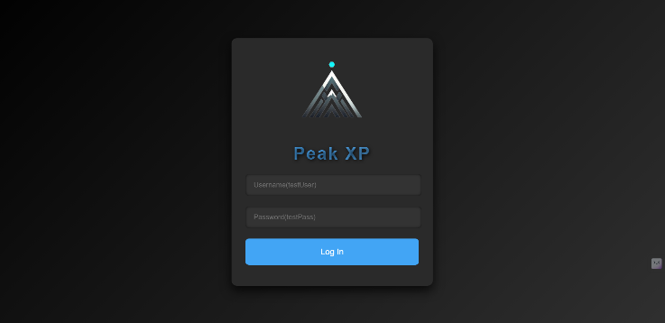Figure 5.1 Login Page Figure 5.2 Home Page

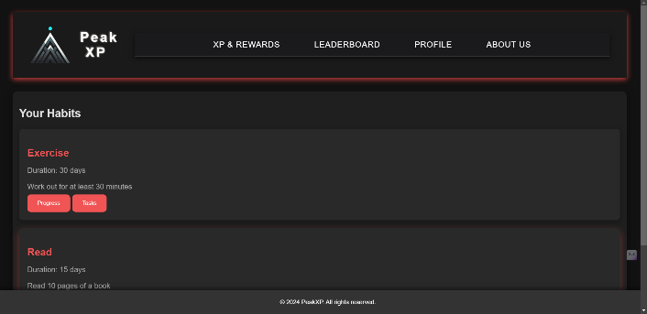

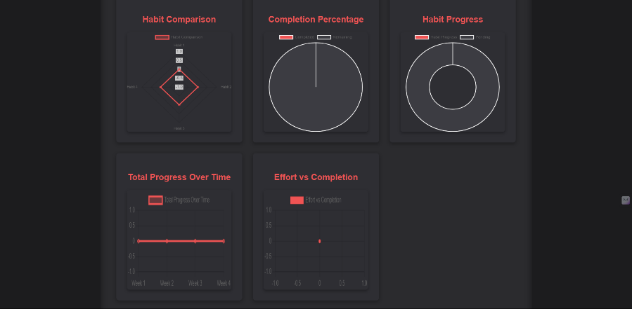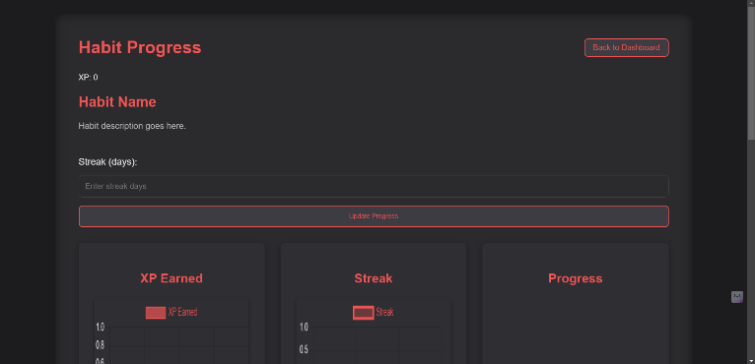Figure 5.3 Habit progress Figure 5.3 Habit progress(graphs)

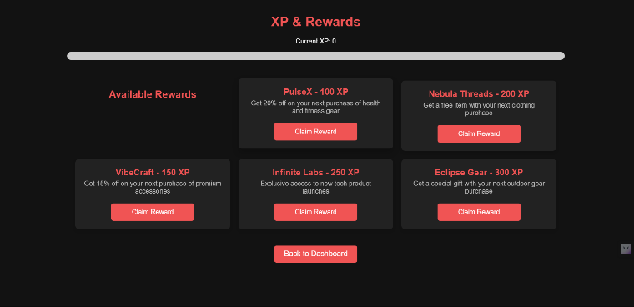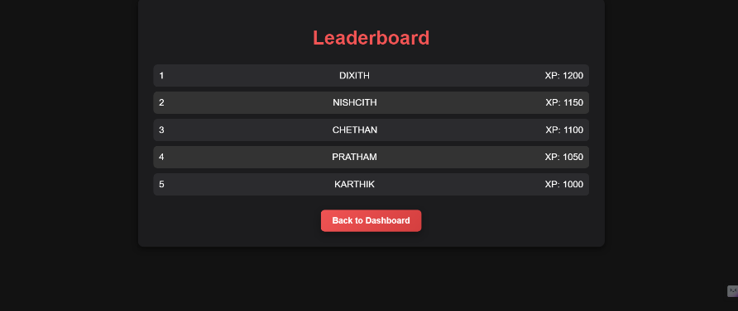 Figure 5.4 XP & rewards Figure 5.5 Leaderboard

**CONCLUSION**

At peak xp, we are committed to revolutionizing the way businesses understand and engage with their users. by focusing on user habits and behaviors, we empower organizations to create digital experiences that are not only intuitive but also habit-forming and engaging. our platform combines advanced analytics, behavioral insights, and ux/ui best practices to help businesses design experiences that resonate with users and drive long-term growth.

through personalized solutions, actionable data, and tailored strategies, peak xp ensures that every user interaction becomes an opportunity for deeper engagement. whether you’re looking to optimize your platform’s user journey, enhance retention, or craft experiences that keep users coming back, our comprehensive suite of tools is here to support your goals.

with the right blend of technology, psychology, and design, we can help you turn user insights into meaningful actions that foster loyalty and encourage lasting habits. at **peak xp**, we don’t just focus on creating digital experiences we focus on creating experiences that inspire, engage, and ultimately thrive.

partner with us to elevate your platform, understand your users better, and unlock the true potential of user habits. together, we can shape the future of digital engagement.